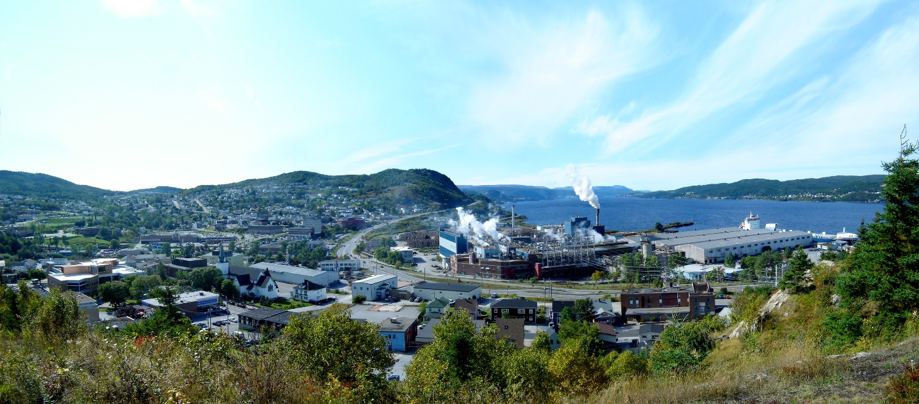

Photo Copywrite: City of Corner Brook

City of Corner Brook

COMMUNITY GRANTS

2019

Community Grant Application

If you have questions, need additional assistance, or have suggestions contact
Finance & Administration
City of Corner Brook
5 Park Street
Phone: 709-637-1512
City of Corner Grant Program Information
Annually, as part of the budget process the City of Corner Brook awards grants intended for programs and events by community organizations. The grant program is intended to provide financial assistance toward projects or events that enhance the quality of life for residents of Corner Brook, and further strategic goals. It is NOT the intent of the City to provide recurrent sustainable funding to any organization.

Program or Event title:
Start and end date:
Summary-Please provide a short description and activities of the proposed project/event (bullets or a short sentence)

Project Budget
Including-Please provide the revenue/expenses and amount requested from the City for the proposed project/event.

TOTAL Project or Event BUDGET $______________

TOTAL AMOUNT REQUESTED FROM THE CITY OF CORNER BROOK $______

Project or Event Alignment:
The current City of Comer Brook’s grant focus is Tourism and Downtown Development, Green Initiatives, and Health and Wellness.
Which area does is your project/event support?

☐ Tourism and Downtown Development Project/Event that draws people to the Downtown or attracts tourists to our City | ☐ Green Initiative Project/Event that will help build an environmentally sustainable City or green initiate | ☐ Health and Wellness Project/Event that improve the health and wellness of the City of Corner Brook citizens

How does it align with the City of Corner Brook’s focus?

Outcomes and Measurement

List the Outcomes:
Project/event related goals and outcomes
1.
2.
3.

What do you want to accomplish?

Measurements
How are you measuring success?

Community Partnerships
What relevant partnerships does your organization have and how do you cost share or support each other?

Community Impact
How does your program or project meet a community need? Does the project or event have a large impact on residents? Explain? Outline the benefits.

Additional Information
- ·Add any other applicable documents strengthen your application
- ·Financial statements, organizational strategic plan, insurance certificate
- ·Current Board of Directors list, proof of incorporation, minutes of most recent Annual General Meeting.

Applicant Signature and title

_______________________ _______________________
Signature Title

☐ I agree to submit a final Grants Accountability Statement/Report at the end of the project including at least 3 high quality digital photos that the City of Corner Brook has rights to publish within 60 days of the project/ event completion.

Organizational Capacity and Description
Organization Description
Please provide a brief description of the organization, mission, collaboration or network and the work you do

Have you previously received City of Corner Brook funding? |  | ¨Yes  ☐ | ¨No  ☐
When did you receive funding |  | Date
How many staff does your organization have?
Is your organization primarily run by volunteers? |  | ¨Yes  ☐ | No  ☐
How many volunteers do you have?____ | Is your organization a registered charitable organization? _____

Organization Contact Information

Organization Name: |  | Mailing Address:
Executive Director Name: |  | Phone Number:
 |  | Email
Board Chair or Treasurer |  | Phone Number:
 |  | Email
Staff contact : |  | Phone Number:
 |  | Email

