Budget 2022

**City of Corner Brook**

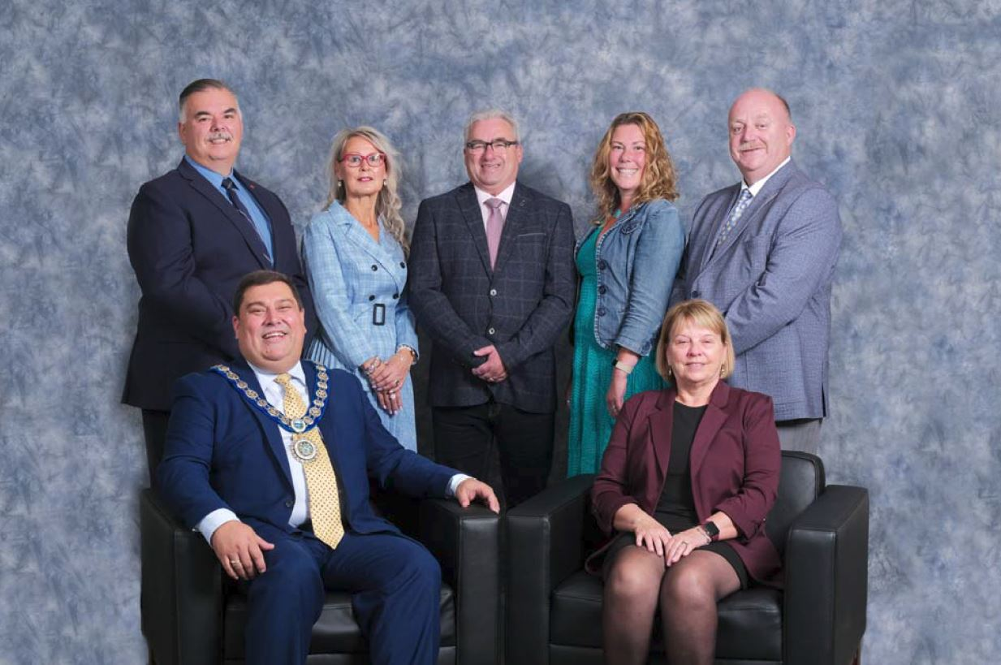

***Front Row Left ‐ Right*:** Mayor Jim Parsons, Deputy Mayor Linda Chaisson

***Back Row Left ‐ Right*:** Councillor Charles Pender, Councillor Pam Keeping, Councillor Bill Griffin, Councillor Pamela Gill and Councillor Vaughn Granter

## Introduction

Mister Mayor, on behalf of Council, I am pleased to present the 2022 Corner Brook Municipal Budget. A budget is always a major undertaking, and more so in the first year of a Council’s mandate. Since the election, less than three months ago, Council has undergone an extensive orientation on the City’s operations and a thorough review of the City’s finances. During the election campaign, members of Council heard from residents, businesses, user groups, and community partners. Each member of Council brings their own priorities and thoughts on the direction they believed the City should take. Budget 2022 has been the product of much hard work by City staff and consensus at the Council table. Consensus and cooperation is key to Council formulating a direction for the City for 2022 and beyond.

## 2021 – A year like no other

Mister Mayor, in last year’s budget, the City stated that 2020 was a year like no other. While that is certainly the case, 2021 has also been an extremely challenging year. The impacts of COVID‐19 have continued throughout this year, and the City

has been required to adapt and adjust. As an organization, the City of Corner Brook has been required to be more flexible to change. From Customer Service, to IT to permitting to Civic Centre and Recreation; all departments have responded to the changing needs and requirements in unprecedented times while maintaining all required safety standards.

Mister Mayor, this responsiveness to change is only able to be achieved due to our employee’s dedication and efforts. On behalf of Council, I will take this opportunity to once again thank all our employees for their efforts not only in 2021 but for all their efforts that we know will come in 2022 as well. Without our staff, nothing that Council plans to do is able to be accomplished.

In the 2021 budget, the City made a number of key decisions to reduce operating expenses to ensure that the City was not going to have a deficit. Additional operational costs combined with reduced revenues required strategic and decisive action. These actions were taken to have the least impact on our resident’s safety and quality of life. Based on current projections, I am pleased to report that the City of Corner Brook is not predicting a deficit for 2021.

## The Economy

Mister Mayor, while the Province as a whole has experienced some economic setbacks in 2020 and 2021, the City continues to grow.

Not only is the City of Corner Brook undertaking significant projects, the Provincial government, community partners and the private sector are continuing to invest heavily in Corner Brook and our region. There are many initiatives from 2021 that we need to highlight.

## Tourism

Mister Mayor, this Council has identified tourism as an area of our economy where the City can play a major role in economic development. The City initiated a project with our regional partners to establish a strategy to increase our tourism assets, with the intention of leading to greater economic benefits for the City and the region. While COVID‐19 has slowed some of these initiatives, a lot of planning and preparation is continuing to take place.

Some of the highlights from 2021 include:

* financial assistance toward the establishment of the Bay of Islands as a UNESCO Global Geopark
* installation of the wildly popular “CORNER BROOK” sign on the White House lawn
* commissioning of the Crow Gulch mural by renowned Indigenous artists Marcus Gosse and Jordon Bennett
* continued investment in our ATV/Snowmobiling/biking trails

2022 will be another exciting year. With COVID‐19 having less of an impact on travel and tourism, we once again expect visitors from far and wide to visit our region.

* Cruise ships are once again expected to visit our now bustling port – there are currently 22 cruise ship visits expected this summer and improvements to the cruise ship corridor from the port to our downtown will be made
* Our downtown summer festival celebrating ATVs, mountain biking and music—*Jigs and Wheels*—is once again being planned
* We will begin the $1.7M Great Trail project connecting the downtown to the western boundary of the City for walking and cycling
* We’ll continue to work through the priorities outlined in the STAR process, including branding, wayfinding improvements and trail development

To that end, Mister Mayor, in 2021, the business tax rate for businesses in the Tourism and Hospitality sector were reduced by 10%. **I am pleased to announce the City will continue with the reduced business tax rates, for approximately 100 businesses in the Tourism and Hospitality sector in 2022.**

Tourism is returning to Western Newfoundland, and we will be ready! Council understands that continued support measures are warranted for the coming year to help our tourism sector come back strong in 2022.

## Post‐Secondary Partnership

Mister Mayor, Corner Brook is proud to be a college city.

As you heard earlier this evening, we are about to embark on the construction of our new Regional Aquatics Centre on Grenfell Campus of Memorial University. This exciting new asset for our community would not be possible without our partnership with Grenfell. Not only are they contributing the land and building for this endeavor, their students, faculty and staff will ensure a solid base of users to keep the Centre sustainable.

Our partnership with the Corner Brook Pulp & Paper, College of the North Atlantic and Grenfell on the Innovation Centre project is really taking shape. The centre is set to open this spring and will be a centre of activity: supporting training at the Mill, research and development activities for the forestry sector, entrepreneurship opportunities, and the educational partnership with the City, known as City Studio.

## Building an Innovative and Modern City Government

Mister Mayor, as a modern municipality, the City of Corner Brook has a duty to do more than just maintain infrastructure, and given our demographic realities, we have to do it with an almost fixed tax base.

IMSP Update

In 2021 the City began the process of undertaking a major update of the City’s Integrated Municipal Sustainability Plan (IMSP) and Development Regulations. The IMSP was first developed in 2012 and has been modified numerous times to reflect

our evolving needs. It is expected that in the first half of 2022, a revised IMSP will be presented to Council for approval. The IMSP will focus on the best practices for dealing with some of the City’s key challenges of Climate Change, Urban Sprawl and Hosing Choices, Aging Infrastructure and Demographic & Economic Uncertainty. This plan will allow residents, developers, businesses and staff to have a common understanding of the objectives and priorities of the City from a development perspective for the next 10 years.

## Building our Community

Health and Wellness

Mister Mayor, our City is here for our people—we should be able to enjoy a safe environment to raise children, pursue our interests and lead long, healthy lives. Investments in recreational infrastructure are an important piece of making our city a happy, healthy home. As COVID‐19 has taught us, the need for a variety of outdoor recreation options is essential to a healthy and vibrant community.

Jubilee Field Clubhouse

In 2021 the City and the Corner Brook Baseball Association were proud to have officially opened the new Jubilee Field Clubhouse. The clubhouse and scorer’s booth are a proper complement to the jewel of the City that is Jubilee Field.

JJ Curling playground

In 2021 the City, with the assistance of Corner Brook Stream Development Corporation completed a major rejuvenation of the JJ Curling playground. The new modern and accessible features include accessible parking, accessible spinner and

surfacing, accessible picnic table, and a new seating area. These improvements will be a template for future improvements we will make at our play areas to ensure they are accessible to all that may wish to enjoy them.

Wellington Street complex

In 2021 the City completed the construction of a multi‐use court at the Wellington Street Recreation Complex. In the summer time, the court will be able to be used for basketball, and during the winter it is expected to be used as an outdoor rink.

Regional Recreational Centre

Mister Mayor, the City received funding for the Corner Brook Regional Recreational Centre in June 2020. Since that time, the City has issued RFP for an owners advisor, issued a RFP for design build teams, selected a preferred proponent to design and build the facility, all while negotiating and discussing the operation of the facility with Grenfell Campus. While there has not been any construction on site yet, all of this preliminary work is almost complete and we expect construction of the new facility to start in early 2022. This will truly be a regional community centre with input and cooperation from our great municipal neighbours in Massey Drive, Steady Brook and Mount Moriah.

Accessibility Improvements

Mister Mayor, ensuring all of our residents have access to the many services and opportunities that our City provides is important. It is critical that accessibility improvements be at the front of our thoughts in everything we do. The City has created an Accessibility and Inclusiveness Committee that includes members of Council, staff and the community. This committee is bringing greater awareness of

the many small and large things that can be done to improve accessibility. The City will continue to make steady progress on addressing accessibility issues. In some cases, the change is not large, but the impact can be significant.

Indigenous Reconciliation

Mister Mayor, in the last number of years, our City has made great strides toward building bridges with the Mi’kmaq people in our area. We were and we are an Indigenous community. It is important to recognize our heritage and educate our citizens, so that we have can foster a strong relationship into the future.

We have partnered with Qalipu First Nation on important projects like Mikwite'tm Garden and the upcoming Participark renovation. We’ve made unprecedented investment in public art to commemorate Crow Gulch through the work of Indigenous artists Marcus Gosse and Jordan Bennett. We’ve made a permanent home for the Mi’kmaq Grand Council Flag in the heart of City Hall.

## Balanced and Fair Taxation

2022 and going forward, every year will be a reassessment year. The Municipal Assessment Agency will conduct annual assessments of properties. This assessment of valuation is used by the City and all municipalities to determine the tax rates that are required to generate the revenues required to operate the City. Annual reassessments will generally mean there will be lower changes in assessed

value than previously with a 3 year assessment cycle, but it will now require a more thorough review of the assessment changes and the impacts on the taxation levels.

In 2020 and 2021, many commercial businesses had many struggles as it adapted to overcome the effects of the pandemic. These challenges are reflected in the assessed values of commercial properties. Overall, commercial properties values decreased by almost 4.0%. In order to adjust for this change, commercial property mil rate is increasing from 12.5 mils to 13.0 mils. The impact of this adjustment is only to offset the lower revenues due to the lower assessed value, and there is not any increased revenues projected for 2022 from the 2021 budgeted amount for this group of properties.

Mister Mayor, as there has been a decrease in the assessments for commercial properties, there has also been a similar decrease in the business tax assessments. Without any adjustment to the business tax mil rates, the City would have been facing a $277,600 or 5.0% decrease in business tax revenues. The City recognizes the value of our business community and understands that many business sectors have been struggling over the past two years. In the 2021 budget, Council initiated a 10% decrease in businesses in the hospitality sector. This reduced mil rate of 15.0 mils will continue in 2022. Additional, the City is freezing the mil rate on an additional 561 businesses in a wide range of business sectors.

Mister Mayor, there are approximately 150 businesses in classifications that Council felt were not as negatively impacted over the past two years, and have an ability to pay that are higher than the general business community. In 2022, there will be adjustments to 6 business class categories to offset the lower assessment

values. The adjustment in mil rates are not creating incremental tax dollars from 2021 level, just maintaining the City’s tax revenues for 2022.

Changes in the mil rate are:

|  |  |  |  |  |  |
| --- | --- | --- | --- | --- | --- |
| **Classification** | **2021 Mil**  **Rate (mils)** | **2022 Mil**  **Rate (mils)** | **2022**  **Change (mils)** | **2022**  **Change (%)** | **#**  **Businesses** |
| Grocery Stores | 25.0 | 27.0 | 2.0 | 8.0% | 8 |
| Professional Operations | 30.0 | 31.5 | 1.5 | 5.0% | 126 |
| Large Retail | 40.0 | 44.0 | 4.0 | 10.0% | 3 |
| Department Stores | 50.0 | 54.0 | 4.0 | 8.0% | 4 |
| Oil Companies | 60.0 | 66.0 | 6.0 | 10.0% | 7 |
| Banks | 100.0 | 108.0 | 8.0 | 8.0% | 10 |

Mister Mayor, even with the increases in the mil rate in the above classifications, business tax revenues for 2022 are still budgeted to be almost $90,000 or 1.6% lower than the 2021 budget.

The City recognizes our residents have also been impacted by COVID‐19, as well as the economic challenges faced by our region and Province. With this in mind, Mister Mayor, I am proud to announce that there will not be any change in the residential property tax mil rate.

Mister Mayor, the City opened the new Water Treatment Plant providing clean and safe water to Corner Brook, Massey Drive and Mount Moriah in 2015. At that time the cost to operate the Water Treatment Plant was $1,156,800. This amount has since increased to $1,542,500 which is $385,700 or a 33% increase. Since this time, there has not been any change in the water and sewer unit charge. For 2022, there will be an increase of $25 per commercial and residential unit charge. This increase will provide $257,000 in incremental revenues that will only partially cover the increased costs of the water treatment plant since 2015.

Once again, the Downtown Business Improvement Area Levy will be set at 0% to give businesses in our City Centre a better opportunity to grow as we invest in our downtown.

## Infrastructure and Capital Investment

Mister Mayor, with hundreds of kilometers of roads, waterlines and sewer, recreational facilities, water treatment facilities, fire protection services, and parks, paths and playgrounds, the City requires consistent capital investment.

Wastewater Treatment

Lack of adequate Federal and Provincial funding mechanisms remains the biggest hurdle as we strive to tackle wastewater treatment. The City will have over

$13,000,000 in reserve for our portion of the capital costs once Federal and Provincial funding becomes available. We have evaluated many different options and scenarios; and none of them are cheap. It can be expected for the capital costs for a wastewater treatment facility will be in the $90 million dollar range! We cannot do this on our own, and must receive Federal and Provincial funding in order to proceed.

Multi-Year Capital Works

Mister Mayor, while the announcement of the Multi‐Year Capital Works funding for 2020‐2023 was delayed in 2020, we are thankful to the Province for the announcement of Provincial funding in 2021 to support $8.25 million in capital projects. The majority of this funding will be utilized in the 2022 calendar year. Projects on this plan include Johnson’s Avenue Storm Sewer, Street Resurfacing, Traffic Intersection Improvements, Blackwood Hill Culvert & Bridge Replacement, Bells Brook Culvert Replacement, and Citadel Drive PRV Upgrades. Engineering work on all of these projects has already started with a target of having these projects tendered early in the first quarter of 2022.

The City also is looking forward to a positive announcement on a major capital project for an $8.0+ million upgrade to the storm and sanitary system on Mount Bernard Avenue.

Mister Mayor In addition to these projects, the City has also submitted another

$16.3 million in projects to our Federal and Provincial partners for additional capital work in 2022, 2023 and 2024. We look forward to a favourable response to all of these applications.

## Fiscal Management and Taxation

Mister Mayor, the City of Corner Brook showed in 2020 that we have the ability to adapt and adjust as required. The budget for 2021 reflected a major reduction in spending from the lessons that were learned in 2020. While the City was able to make some short term spending cuts, long term cuts in spending will have a tremendous negative impact on the service level we provide to our residents, as well as on the life span of our assets. It is far more cost effective to maintain our assets than it is to replace our infrastructure.

A Balanced Budget

As is required by the City of Corner Brook Act, the 2022 budget is a balanced budget of $35,558,100. The budget for 2022 is $137,500 or just 0.39% higher than the 2021 budget, and $1.0 million lower than the 2020 budget.

Debt Servicing

Mister Mayor, the City’s debt servicing is a major annual cost to the City. Debt financing is incurred by the City on capital projects in order to manage the cash flow of the City. While the City receives funding for the majority of its capital projects, this funding is never enough to fully cover the cost of the projects. Typical funding assistance represents anywhere from 50 to 75% of the total budgeted

costs. Debt payments required by the City for its share of capital projects is budgeted to decrease by $894,100 to $3,281,600 in 2022. This represents only 8.85% of our annual expenditures being required to pay our existing debt. This is the lowest debt percentage in recent memory. While the 2022 debt payments are reduced, it is expected that debt payments in 2023 and 2024 will increase as significantly more investment is made in capital projects in 2022 and 2023, including the much anticipated Regional Recreation Centre. By 2024, debt payments are expected to increase by $1.15 million or 35%.

The total debt at the end of 2021 is projected to be $7,500,000 and by the end of 2022 it is expected to increase by $2,600,000 to $10,100,000.

## Conclusion

Mister Mayor, this budget is the beginning of the new Council laying out a plan and strategy for the next 4 years. The areas of focus in this budget of: tourism growth, accessibility, improved recreation and cultural opportunities, combined with sound financial management will lead us throughout this Council’s mandate. While there will be adjustments along the way, these key areas are expected to be at the forefront of our thoughts in the decision making process. On behalf of all of Council, I again thank everybody for their valuable contribution to the budget process.

As required by legislation and sound long term financial planning, our budget today is a balanced budget. I would now like to make the following four motions:

* Be it RESOLVED that the City of Corner Brook, in accordance with *The City of Corner Brook Act,* approve the attached tax rates for the 2022 taxation year.
* Be it further RESOLVED that the City of Corner Brook, in accordance with *The City of Corner Brook Act*, approve the attached Schedule of Rates & Fees, to take effect January 1, 2022.
* Be it further RESOLVED that the City of Corner Brook, in accordance with *The City of Corner Brook Act*, approve an annual rate of interest of 10.5% to be levied on all past due taxes and accounts receivable on a monthly basis in 2022.
* Be it further RESOLVED that the City of Corner Brook, in accordance with *The City of Corner Brook Act,* approve the 2022 Budget with operating Revenues and Expenditures totalling $35,588,100.

# CITY OF CORNER BROOK 2022 TAX RATES

1) **A REAL PROPERTY TAX** of not less than $275 on every parcel of real property within the City, and every parcel of real property outside the City which is situated on, in or over, or under water and is accessible from land within the City; and the rate of tax shall be, subject to the minimum property tax:

**Fully Serviced (Water and Sewer) - Commercial** -13.0 mils plus $660 per unit water and sewer which includes a $100 sewer levy.

**Fully Serviced (Water and Sewer) - Residential –** 8.25 mils plus $580 per unit water and sewer which includes a $100 sewer levy.

**Partially serviced (Water Only) - Commercial –** 9.5 mils plus $470 basic charge per unit.

**Partially serviced (Water Only) - Residential –** 5.25 mils plus $390 basic charge per unit.

**Unserviced** – 5.0 mils only

**Unserviced** – **Watson Pond Industrial Park** – fire protected area - 8.0 mils only

**Metered** – 6.0 mils plus meter rates

**Non-Taxable** - Water and Sewer Rates only – 6.5 mils plus $660 basic charge per unit which includes a $100 sewer levy.

**Trailers** - A real property tax rate of 5.75 mils.

All taxes so imposed shall be based upon the value of the real property so taxed as set down in the last assessment roll of the City, prepared in accordance with the provision of the Assessment Act, 2006, (which real Property Tax shall be added to the Water and Sewer charges to constitute the Municipal Tax in accordance with established policy).

1. (i) **A BUSINESS TAX** shall be imposed on all individuals, partnerships, associations and corporations carrying on business in the City and the rate of Business Tax so imposed for each class of business (as attached) shall be fixed at:
   1. 10.8% (108.0 mils) Chartered Banks, Financial Institutions
   2. 6.6% (66.0 mils) Oil Companies Bulk Storage Facilities
   3. 5.4% (54.0 mils) Department Stores
   4. 4.4% (44.0 mils) Large Retail
   5. 4.0% (40.0 mils) Insurance Companies
   6. 3.15% (31.5 mils) Professional Operations
   7. 3.0% (30.0 mils) Communications, Private Schools
   8. 2.7% (27.0 mils) Grocery Stores,
   9. 1.675% (16.75 mils) General Commercial and Industrial – including:

Car Sales, Commercial Garages/Automotive & Parts Sales & Repair Shops, Service Stations, Transportation Depots/Trucking Companies, Transportation Terminals, Convenience Stores/Gas Bars, Drug Stores, Dispensaries, Clothing Stores, Computer Sales, Electronic Repairs and Electronics Sales, Jewellery Stores, Music Stores, Shoe Stores, Sporting Goods/Equipment, Video Shops, Retail-Other, Hardware Stores, Building Supplies, Furniture/Carpet Stores, Wholesalers, Warehouses, Monument Sales, Construction Companies/Services, Daycare Services, Personal Services, Bakeries, Barber Shops/Beauty Salons, Convenience Stores, Custom Workshops/Repairs, Retail-Residential, Repairs/Commercial, Recycling, Book Stores, Dry Goods/Fabric/Flower Shops, Photo Shops,

Fish Harvesting & Processing, Industrial, and All Other

* 1. 1.5% (15.0 mils) Hospitality – including: Bed & Breakfasts and Hospitality Homes, Car Rentals, Hotels, Motels, Taxi Businesses, Restaurants,

Takeout Food Services, Taverns, and Places of Amusement

* 1. 0.4% (4.0 mils) Nursing Homes

per annum of the assessed value of real property used by all individuals, partnerships, associations and corporations carrying on business, trade, or profession in respect of which a tax is imposed as determined by the Assessor, using the City assessment for real property assessed from time to time under the City of Corner Brook Act, 1990, and the Assessment Act, 2006.

1. 2.5% of gross revenue - All businesses subject to taxation under the Taxation of Utilities & Cable Television Companies Act
2. Where the real property tax is not applicable to a business because it has no fixed place of business, the business tax shall be set at the minimum rate of 2.5% of the gross revenue of the business as set forth in Section(s) 146 and 150 of the City of Corner Brook Act, RSNL 1990 Chapter C-15.
3. Where the amount of tax calculated under (i) or (ii) above is less than $270, the minimum business tax shall be set at $270.
4. **MONTHLY METERED WATER RATES** shall be $4.00 for each 1,000 gallons (4,546 litres).
5. **DEFERRALS AND DISCOUNTS FOR SENIOR CITIZENS** shall be granted for domicile properties in accordance with the following formula:

Age 65 and over - Pay $580 per unit, subject to taxable income not exceeding

$12,500 for single pensioner or $14,000 for married pensioner and total income not exceeding $24,000, and the balance of taxes can be deferred.

For the purpose of computing income, prescription drugs to the value of $700 for a single person or $1,400 for a couple may be considered if supported by receipts.

All requests for deferrals must be supported by a copy of the Notice of Assessment from Canada Customs & Revenue Agency for the 2021 tax year. For the purposes of determining eligibility for the deferral, senior citizens 65 years and over may have one wage earner living in their dwelling, earning up to $24,000 per year. Any other applicants would be subject to review of Council.

Senior citizens who will be 65 years of age or over during the 2022 fiscal year (1 January - 31 December 2022) will be entitled to a 15% discount off their Municipal Tax if they are in receipt of the Guaranteed Income Supplement (GIS) under the Old Age Security Act. Seniors citizens in receipt of the GIS are eligible for an interest free payment plan if all of the 2022 taxes are paid by June 30, 2022. To be eligible for the interest free payment plan, 20% of the outstanding taxes for 2022 are to be paid in February, March, April, May and June via post-dated cheques or pre-authorized payment.

The residential property must be their principal place of residence or the home must be permanently vacant. Discounts and deferrals will not be granted on property which is rented. The applicant must be the assessed owner of the property. Discounts will not be applied to interest or arrears. At no time is the amount of the taxes deferred to exceed the assessed value of the property.

1. **WIDOWS’/WIDOWERS’ DEFERRAL** shall be based on taxable income of $12,500 or less plus $1,350 for each dependent up to a maximum of three dependents, total income not to exceed $24,000. The basic charge of $580 per unit shall apply. Proof of income

and conditions are required as for senior citizens’ deferral. Any other applicants will be subject to review of Council. At no time is the amount of the taxes deferred to exceed the assessed value of the property.

1. **DISABLED PENSIONERS** shall receive the same deferral under the same conditions as widows, except they shall be allowed $1,000 additional income for their spouse.
2. **A DISCOUNT** OF 1.0% shall be allowed on any Municipal Tax (Property and Water and Sewer Tax) paid in full, by cash, cheque or debit card, on or before February 28, 2022 and on any Business Tax paid in full, by cash, cheque or debit card on or before March 31, 2021.
3. **INTEREST ON ACCOUNTS:**

The interest rate will be 10.5% per annum. Interest will be applied monthly, to all accounts in arrears effective 1 January 2022. Such interest will be applicable to current year taxes effective February 28, 2022 for Municipal Tax, and March 31, 2022 for Business Tax. Interest will be calculated from date of tax billing. Any current year taxes paid prior to the discount date will not be charged interest. No discounts will be applied to interest charges.

1. **BUSINESS IMPROVEMENT AREA:**

A zero percent (0%) surcharge shall be imposed on the Business Tax levy, up to a maximum of $1,000 per annum, in accordance with the Business Improvement Area Legislation.

1. The fee for tax certificates is $100.

# COMMUNITY, ENGINEERING, DEVELOPMENT & PLANNING and PROTECTIVE SERVICES FEES

**2022**

## Development and Inspection

**Residential Construction:**

Regular Rate 0.6% of construction value

**New Home:**

Main Floor Area $5.00/m2

Finished floor above main floor area $1.40/m2

Finished floor below main area $1.40/m2

Basement $1.40/m2

Attached Garage $1.40/m2

Basement Apartment $1.40/m2

Unfinished floor area No Fee

Residential Landscaping Deposit No Fee

**Alterations / Extensions / Repairs:**

Up to $5,000 $30.00

Over $5,000 0.6% of construction value

**Residential Permits**

Patio / Deck / Pool $30.00

Retaining Wall / Driveway $30.00

Accessory Buildings up to $5,000 $30.00

Accessory Buildings over $5,000 0.6% of construction value

Subsidiary Apartment $1.40/m2

**Commercial / Industrial / Institutional**

Up to $300,000.00 0.75% up to $300,000 of construction value

Over $300,000.00 0.75% up to $300,000 of

construction value and 0.6% over $300,000

Extensions $50.00 (minimum fee) or

Commercial Regular Rate

Alterations, Repairs $30.00 (minimum fee) or Commercial Regular Rate

Accessory Building $30.00 (minimum fee) or Residential Regular Rate

Sign permit

Up to $5,000.00 $30.00

Over $5,000.00 0.6% of construction value

Commercial Landscaping Deposit $4.00/sq m of lot area to a maximum of $5,000.00

**Development:**

|  |  |
| --- | --- |
| Development Application Fee Subdivision or Consolidation of Property Change of Use or Use Approval | $100.00  $100.00 + $25.00 per lot  $300.00 |
| Medical, Professional and Personal Services uses | $50.00 |
| (Not applicable in Residential Zones where public notices are required) | |
| Compliance Letters | $100.00 |
| Temporary Use Permit | $100.00 |
| Commercial Demolition approval | $50.00 |
| Residential Demolition approval | $50.00 |
| Development Regulation Amendment | $1,000.00 |
| Municipal Plan Amendment/Rezoning  Appeals Fee  Public Notice (Variances & Discretionary) | $1,500.00  $100.00 plus HST  $300.00 |

|  |  |
| --- | --- |
| **Municipal Enforcement**  Taxi Driver License | $25.00 |
| Taxi Vehicle License | $50.00 |
| Delivery Service Permit | $25.00 |
| Bagging a Meter  Parking Meter Fees | $6.00  $1.00 per hour |
| **Parking Tickets**  Expired Meter  If paid 24 hours before the Court Date at City Hall | $25.00 |
| If not paid 24 hours before the Court Date at City Hall  it is to be paid at Provincial Court | $35.00 |
| Overnight Parking | $50.00 |
| No Parking | $20.00 |
| Obstructing Traffic | $45.00 |
| Parking at a Bus Stop | $45.00 |
| Parking on a Sidewalk | $45.00 |
| Parking in Front of a Driveway or Loading Zone | $45.00 |
| Parking within Intersection, or within 6 metres of Intersection | $45.00 |
| Parking too close to a Fire Hydrant | $45.00 |
| Parking within Crosswalk | $45.00 |
| Parking within 6 metres of an Approach to a Crosswalk | $45.00 |
| Double Parked | $45.00 |
| Parking on Private Property without Permission | $45.00 |
| No Stopping / No Parking | $100.00 |
| Parking without Permit in Designated Space | $45.00 |
| Parking in an Accessible Parking space without a permit | $400.00 |
| **Animal Control** |  |
| Dog License – Regular Fee (3 year license) | $25.00 |
| Less: Discount if dog is spaded or neutered | $10.00 |

|  |  |  |  |  |  |
| --- | --- | --- | --- | --- | --- |
| Less: Discount if dog has identity chip | | $5.00 |  | | |
| **Animal Regulations Violation Notices – Fees** | |  |
| Dog without a license / tag | | $50.00 |
| Dog depositing excrement on street or property | | $25.00 |
| Dog causing damage | | $25.00 |
| Dog disturbing the peace by barking or howling | | $25.00 |
| Impounding fee | | $10.00 |
| Interference with Impounder | | $500.00 |
| Dog biting, attacking or injuring | | Appear | in | court | when |
|  |  | summoned | | | |
| Dog/cat roaming at large: |  |  | | | |
| 1st offence | Licensed  $50.00 | Unlicensed  $75.00 | | | |
| 2nd offense | $75.00 | $100.00 | | | |
| 3rd offense | $100.00 | $125.00 | | | |

**Mobile Vending / Transient Businesses**

Automobiles, Recreational Vehicles, Hot Tubs, Furriers, Fireworks:

Per day $200

Per week $1,000

Prepared Foods:

Per year $250

All other mobile vending / transient Businesses:

|  |  |
| --- | --- |
| Per day | $25 |
| Per week | $125 |
| Per month | $400 |
| Per 3 months | $800 |

Per calendar year $1,500

## Civic Centre

Ice Rental rates (all rate are exclusive of HST):

January 1 – September 5, 2022

Early morning ice (Monday – Friday 5:00 am to 8:00 am) $ 61.20 Morning ice (Monday – Friday 8:00 am to 11:30 am) $111.22 Regular rates (11:30 am to 10:30 pm, and all weekends) $185.42 Late night rates (10:30 pm to 5:00 am) $158.96

Minor programming $147.90

September 6 – December 31, 2022

Early morning ice (Monday – Friday 5:00 am to 8:00 am) $ 62.42 Morning ice (Monday – Friday 8:00 am to 11:30 am) $113.44 Regular rates (11:30 am to 10:30 pm, and all weekends) $189.13 Late night rates (10:30 pm to 5:00 am) $162.14

Minor programming $150.86

**DEFINITIONS OF CLASSES OF BUSINESS – 2022**

ALL OTHER means businesses not identified under any other specific category or where the nature of the business is unknown.

BAKERY means a factory for producing, mixing, compounding or baking bread, biscuits or any other bakery product, but does not include a restaurant or other premises where any such product is made for consumption on the premises.

BANK means any chartered bank.

BARBER SHOP /BEAUTY SALON means a building or part of a building where haircutting, hairdressing, manicure, pedicure, skin care, and other grooming services are provided.

BED & BREAKFAST/HOSPITALITY HOME means rooms for rent in a private home as a tourist establishment.

BOOK STORE means an establishment retailing primarily, but not limited to, new or used books and magazines.

BUILDING SUPPLIES means an establishment including, but not limited to, the sale of hardware and tools, lumber, windows, siding, bricks, paint, cement, roofing shingles, tiles, bathroom supplies, electrical and plumbing supplies.

CALL CENTRE means an establishment providing services and seeking business through the telephone and/or computer network.

CAR SALES LOT means a building or open area used for storage, display and sale purposes, of motor vehicles, and includes ancillary services associated with automobile sales, such as repair and servicing, and sales of automotive parts.

CAR RENTALS means a building or part of a building or open area where automobiles are stored for rental and the offices for conducting such business is maintained.

CLOTHING STORE means an establishment retailing men’s, women’s and/or children’s clothing and outerwear.

COMMERCIAL GARAGE (including automotive & parts sales & repair shop) means a building

or part of a building, other than a private garage, used for the sale, repair or maintenance of automobiles, equipment or other self-propelled vehicles, heavy equipment, trailers and parts thereof, or where such vehicles are kept for remuneration, hire or sale. It includes, but is not limited to, body shops, muffler shops, mobile welding, and automobile glass. This definition does not include businesses whose primary business is automobile sales.

COMMUNICATIONS means any establishment or facility in the field of communications, including publishing companies, printing businesses, radio stations, television stations, telephone, and internet companies.

COMPUTER SALES means an establishment retailing computers and any related hardware or software.

CONSTRUCTION COMPANY/SERVICES means a construction company or business providing goods and services to the construction industry, including but not limited to, electricians, plumbers, roofers, companies providing siding, paving, excavation, rental of equipment and vehicles, heavy equipment and trucking.

CONVENIENCE STORE means a retail store which is compatible with a residential area or uses not exceeding a floor area of 200 m and in which at least 80% of the retail floor space is devoted to the sale and display of groceries.

CONVENIENCE STORE/GAS BAR means a retail store which is compatible with a residential area or uses not exceeding a floor area of 200 m and in which at least 80% of the retail floor space is devoted to the sale and display of groceries, and includes pumps for retailing gasoline.

CUSTOM WORKSHOP/REPAIRS means a shop used for repairing or servicing household goods or for the manufacture of handcrafted goods and may include a retail store associated with the use.

DAYCARE SERVICES means a building or part of a building in which services and activities are regularly provided to five (5) or more children of pre-school age during the full daytime period as defined under the Day Care and Homemaker Services Act of Newfoundland, but does not include a school as defined by the Schools Act.

DEPARTMENT STORE means a retail establishment which is not limited to the sale of any specific items, but carries a variety of goods including, but not limited to clothing, footwear, household items, large and small appliances, hardware, personal care, jewelry, gifts, and

may include furniture, computers and related equipment.

DISPENSARY means an establishment for the purpose of dispensing prescriptions by a pharmacist.

DRUG STORE means a retail establishment which includes the services of a pharmacist for the purpose of dispensing prescriptions, and which includes, but is not limited to, items for personal, skin and hair care, cosmetics, perfumes, confectionery and may include a section for the sale of grocery items and produce, but does not include the sole operation of a dispensary.

DRY GOODS/FABRIC/FLOWERS means an establishment which primarily sells a limited number of product types which may include, but is not limited to, ceramics, art galleries, gifts and crafts, art, crafts and hobby supplies, costume rentals, yard goods, flowers and floral arrangements, lottery tickets, collectibles, pets and pet supplies, brewing and winemaking supplies, but does not include department and clothing stores, and other stores defined in specific categories.

ELECTRONIC REPAIRS/SALES means an establishment for the sale, repair and maintenance of electronic equipment.

FISH HARVESTING AND PROCESSING means any building or location used for harvesting, processing, preparing, packing, freezing, storing, warehousing, shipping, sales or administration of any fish or seafood product.

FURNITURE/CARPET STORE means an establishment for the sale or rental of household furniture, appliances, carpets, rugs and flooring.

GROCERY STORE means an establishment for the purpose of retailing groceries, produce, fish, meat, baked goods, dairy products, and may include household and kitchen items, personal care products, magazines, and flowers.

HARDWARE STORE means an establishment including, but not limited to, the sale of hardware and tools, and may include paint, small appliances, household goods, lighting fixtures, automotive supplies, electrical and plumbing supplies.

HOTEL/MOTEL means a building with lodging accommodations and other services for travelers and tourists.

INDUSTRIAL means the use of land or buildings for the purpose of manufacturing, fabricating, assembling, altering, repairing, packing, canning, storing, breaking up, demolishing, or treating any article, commodity or substance, and industry shall be construed accordingly.

INSURANCE COMPANY/AGENT means any person, broker or business engaged in the business of providing life, automobile, property, liability, commercial, marine insurances services and insurance claims and adjusting services

JEWELRY STORE means an establishment for the sale of jewelry, fine china, silver, crystal, clocks and watches.

LARGE RETAIL means any retail establishment besides those included in DEPARTMENT STORE and GROCERY STORE operating from an area in excess of 45,000 square foot.

MONUMENT SALES means an establishment for the sale of granite, marble, bronze or other monuments, plaques or memorials.

MUSIC STORE means an establishment for the sale of musical instruments and equipment, recorded music and related supplies.

NURSING HOME means a privately-owned and operated residence which provides accommodation and/or care for the elderly.

OIL COMPANY BULK STORAGE FACILITIES means a company who stores and supplies gasoline, oil and oil products to residential, commercial and industrial establishments.

OTHER FINANCIAL INSTITUTIONS includes trust companies, credit unions and finance companies, but does not include chartered banks.

PERSONAL SERVICES means a business providing services including, but not limited to, laundry and dry cleaning, fitness, shoe repair, tattoo parlours, dressmaking and sewing repairs, travel agents, household moving and storage companies.

PHOTO SHOP means an establishment for the sale of photographic equipment and supplies, development and processing of film, and may include the taking of passport photos and portraits.

PLACE OF AMUSEMENT includes a motion picture or other theatre, public dance hall, music hall, bingo hall, arcade, billiard or pool room, bowling alley, ice or roller skating rink or similar use conducted within an enclosed building. This category would include businesses within the definition of tavern who offer amusement uses as defined in this category.

PRIVATE SCHOOL means any facility used for the purpose of providing instruction or training in a course of study, but excludes a provincial school as defined by the *Schools Act,* 1997, as amended.

PROFESSIONAL BUSINESS means a business that offers specialized knowledge or services that are advisory in nature or may be provided by individuals who are licensed members of a self-regulating association. Such individuals would include, but is not limited to: doctors, physiotherapists, chiropractors, other medical practitioners, dentists, lawyers, accountants, engineers, appraisers, financial/investment advisers, undertakers, real estate agents, architects, surveyors, and management or computer consultants. Where a retail component applies, the retail designation may apply at the decision of Council.

RECYCLING means a business which recovers useful material for recycling on the premises or for shipping to a recycling plant.

REPAIRS/COMMERCIAL means a business providing repair services to commercial establishments including, but not limited to, refrigeration.

RESTAURANT means a building or part thereof, designed or intended to be used or occupied for the purposes of serving the general public with meals or refreshments for immediate consumption at individual tables or booths; and may include the sale of spirits, wines or beers with meals but shall not include the exclusive sale of spirits, wines or beers for consumption on the premises, and does not include a tavern, boarding or lodging house.

RETAIL - RESIDENTIAL means a retail store within a dwelling unit, with the retail floor space not exceeding 50 m2 or 50% of the floor area of the dwelling unit, whichever is less.

RETAIL - OTHER means a building or part of a building where goods or items are offered for sale at retail prices, and includes storage on or about the store premises of limited quantities of such goods or things sufficient only to service such store.

SERVICE STATION means any building used for the sale or installation of petroleum products, automotive parts and accessories and motor vehicle repair, and may include a

convenience store or restaurant associated with the main use. This definition does not include a commercial garage, car sales lot or car washing establishment.

SHOE STORE means an establishment for the sale of footwear.

SPORTING GOODS/EQUIPMENT means an establishment for the sale of sporting goods, clothing, and equipment. This definition does not include a store which primarily sells sportswear and footwear without sports equipment.

TAKEOUT FOOD SERVICES means any retail establishment which sells prepared food not for consumption on the premises, or which does not offer self-maintained seating space.

TAVERN means a building which is primarily used or occupied for the purpose of selling or offering for sale, to the general public, of spirits, wines or beers for consumption on the premises and licensed or is licensable under the Liquor Control Act of Newfoundland, and any regulations made there under.

TAXI BUSINESS means a lot, with or without buildings, for the parking of taxicabs as defined in the City of Corner Brook Taxi By-Law.

TRANSPORTATION DEPOT/TRUCKING COMPANY means any station or lot used for the purpose of storing, servicing or refueling of vehicles connected with the transportation business, and any business involved in the transportation of goods by air, water or ground; but does not include a commercial garage.

TRANSPORTATION TERMINAL means any station for the use of transportation facilities available to the general public, including bus terminals.

VIDEO SHOP means an establishment for the rental of video equipment, movies and electronic games, and may include the sale of snacks and confectionery.

WAREHOUSE means a building or part of a building which is used for the housing, storage, display, adapting for sale, packaging or wholesale distribution of goods, wares, merchandise, foodstuffs, substances, articles or things.

WHOLESALER means an establishment which sells goods, usually in quantity, to retailers for resale.



*Classifications for Business Tax will be reviewed annually by Council, and classification is subject to change at Council’s discretion.*

*If a business falls into more than one category, Council reserves the right to assign the business to that category which it feels is most appropriate.*

*In case of a dispute as to the classification of a particular business, the business may appeal to the Finance & Administration Standing Committee who will make a recommendation to Council.*

**THE CITY OF CORNER BROOK RECOVERABLE WORK RATES**

All property owners will be invoiced for actual costs incurred by the City of Corner Brook. The owner shall pay a deposit prior to the commencement of the work based on an estimated cost of the type of work being performed. If the actual cost of the work is less than the deposit, a refund will be made. Where the actual cost is greater than the deposit, property owners are required to pay the remaining balance upon receipt of an invoice.

A fixed cost will be charged for the following services only:

1. Turn off or turn on water rates are separated as per the following (per visit):
   1. The rate of **$105.00** will be applied during normal working hours.
   2. The rate of **$135.00** will be applied outside of normal working hours.
2. The rates for clearing of sewer service laterals are as follows:
   1. The rate of **$195.00** is applicable where the sewer has to be rodded or taped during normal working hours.
   2. The rate of **$285.00** is applicable where the sewer has to be rodded or taped outside of normal working hours.

In the case that the sewer has to be excavated, the property owner is expected to pay

**37 |** P a g e **C i t y o f C o r n e r B r o o k B u d g e t 2 0 2 2**

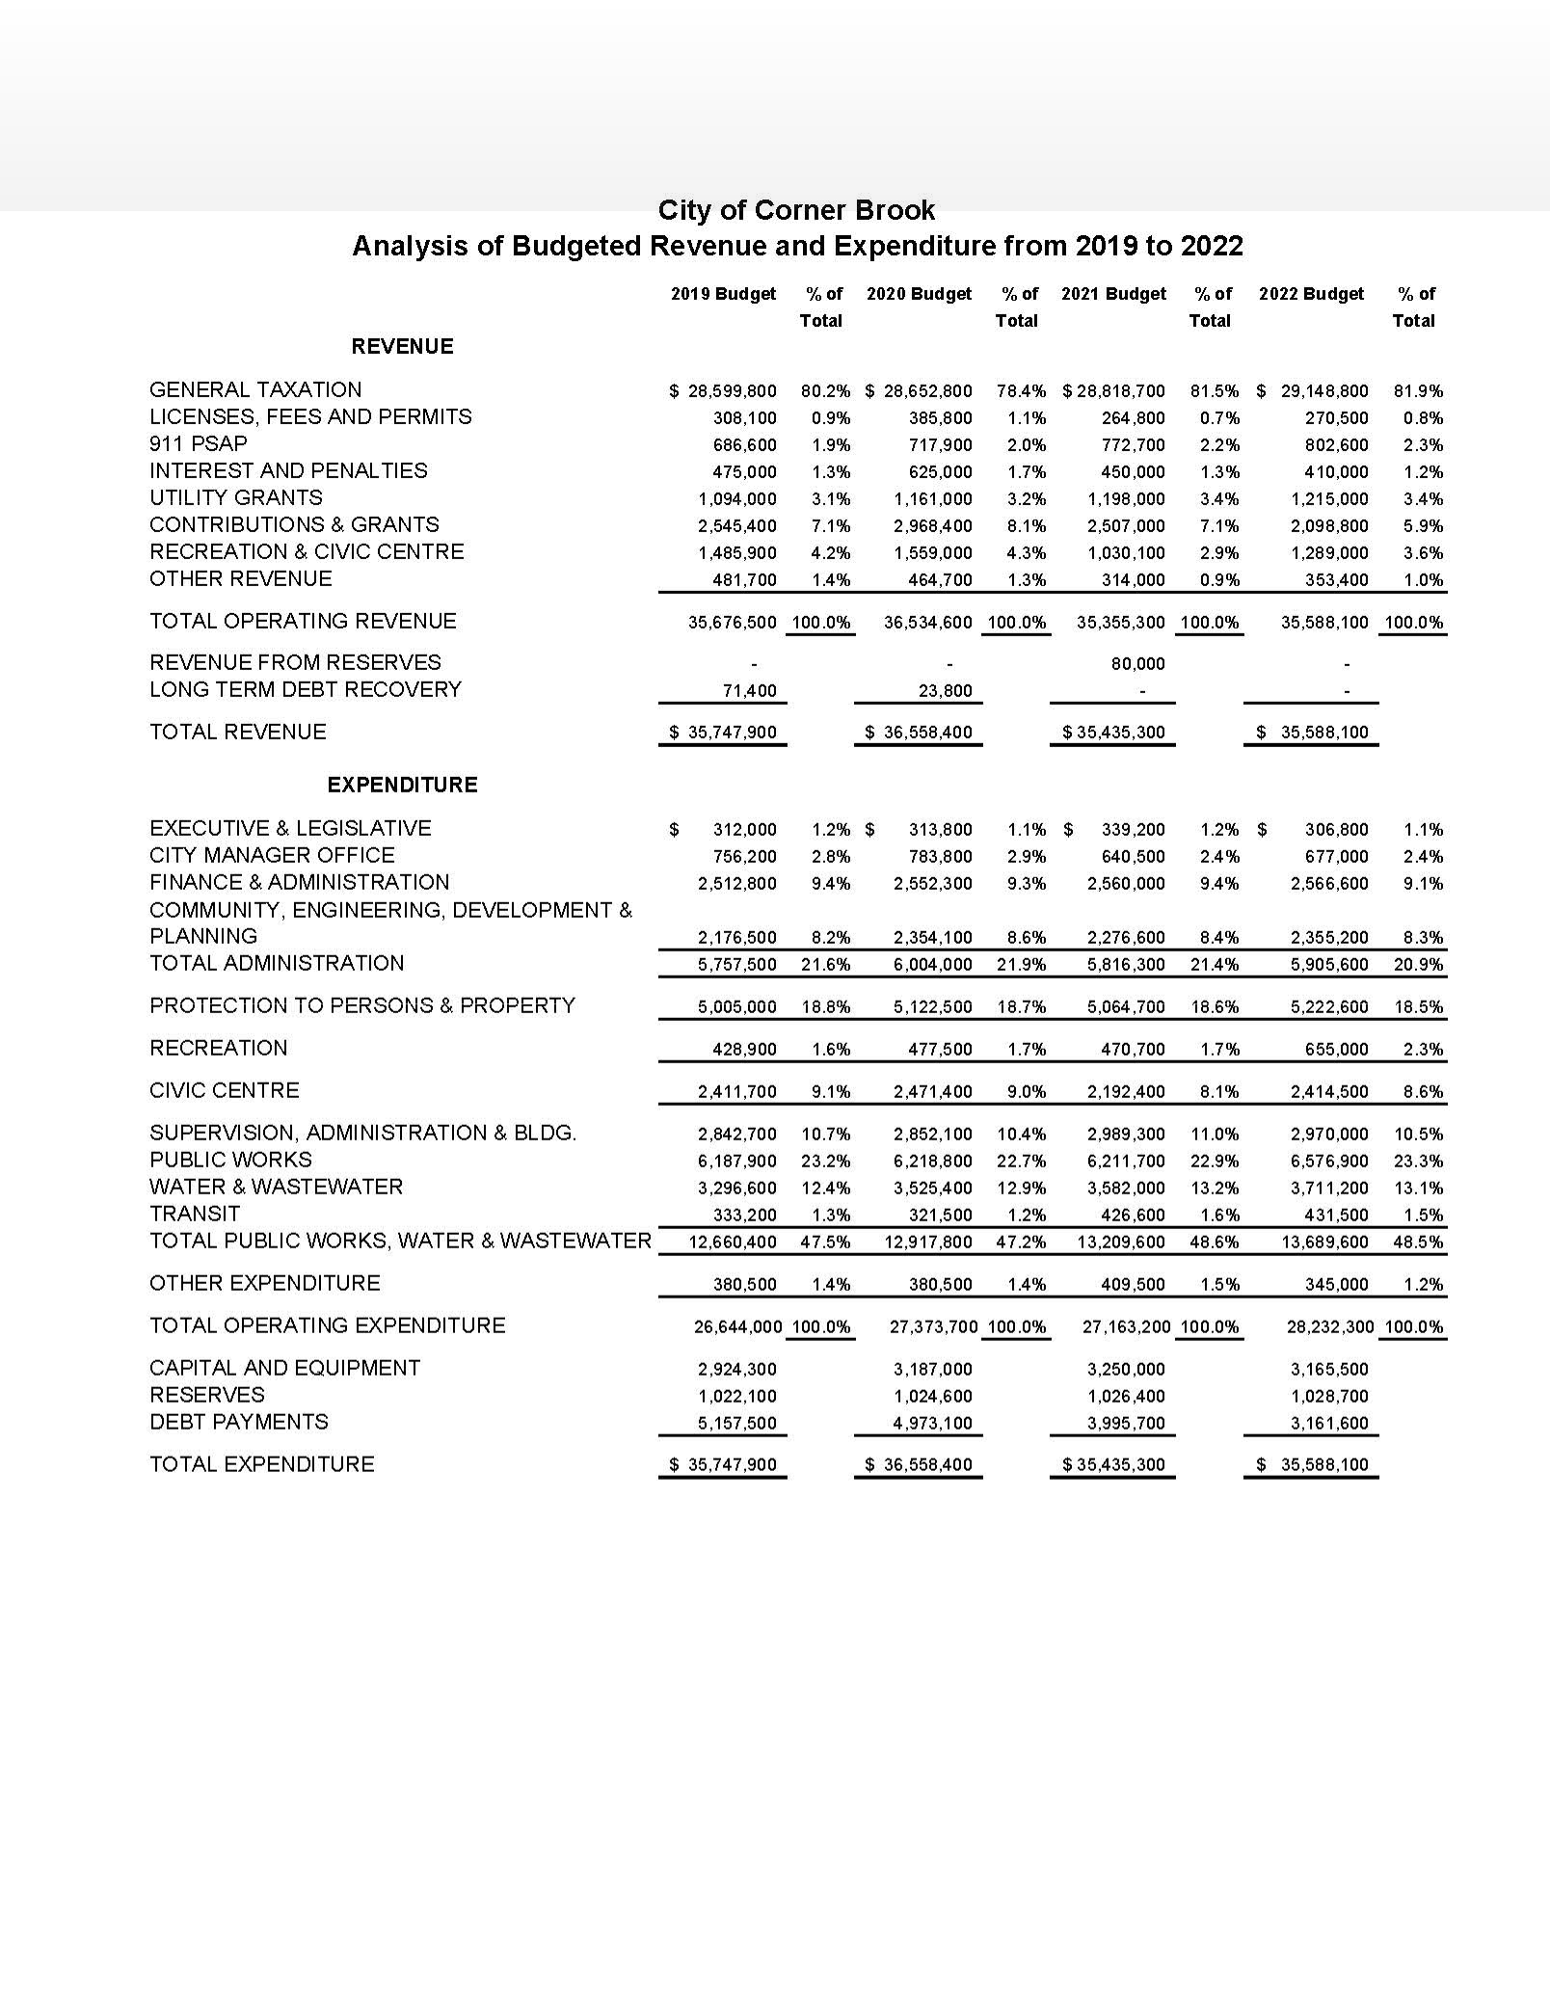

**38 |** P a g e **C i t y o f C o r n e r B r o o k B u d g e t 2 0 2 2**

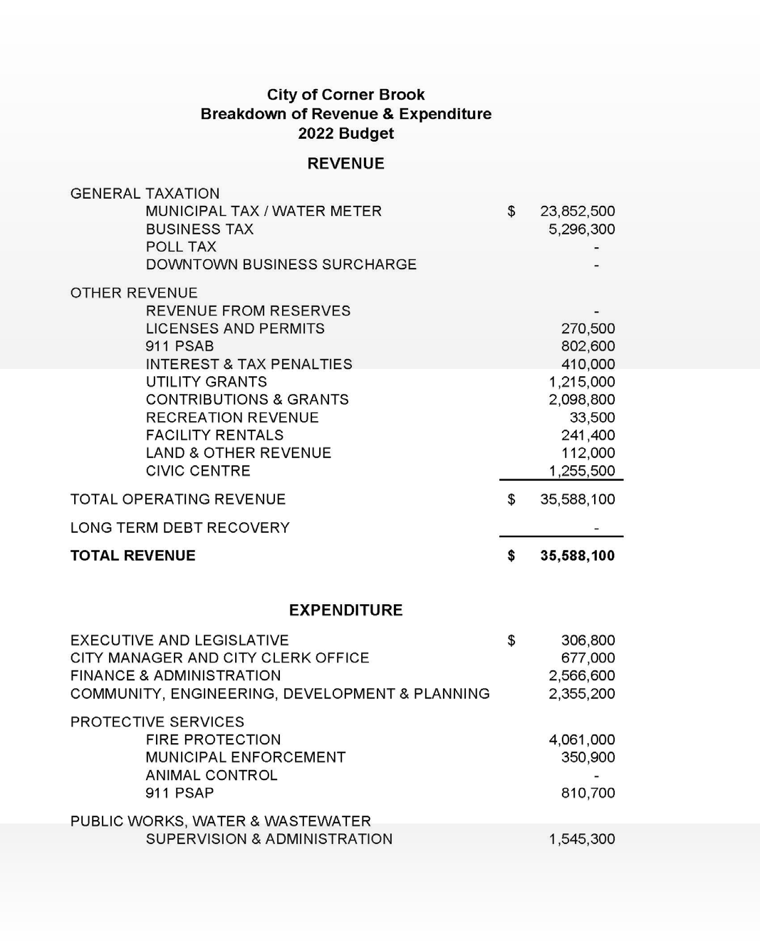

**39 |** P a g e **C i t y o f C o r n e r B r o o k B u d g e t 2 0 2 2**

